AREA 3
2016 AREA CONVENTION & CONTEST

APRIL 29, 30 & MAY 1, 2016
FAIRPORT, NY

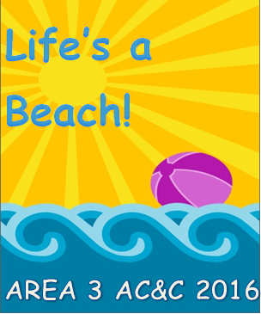

AREA 3’s ACCT. [Area Convention & Contest Team]

and Hostess Chapter, NIAGARA FRONTIER CHORD AUTHORITY,

Welcome you to

LIFE’S A BEACH!

Included in this 3rd mailing:

====================

Final Weekend Schedule
Riser Clarification
Safe Travels
Entrance and Entrance Times
Music Boosters Food Sales
Contest Etiquette

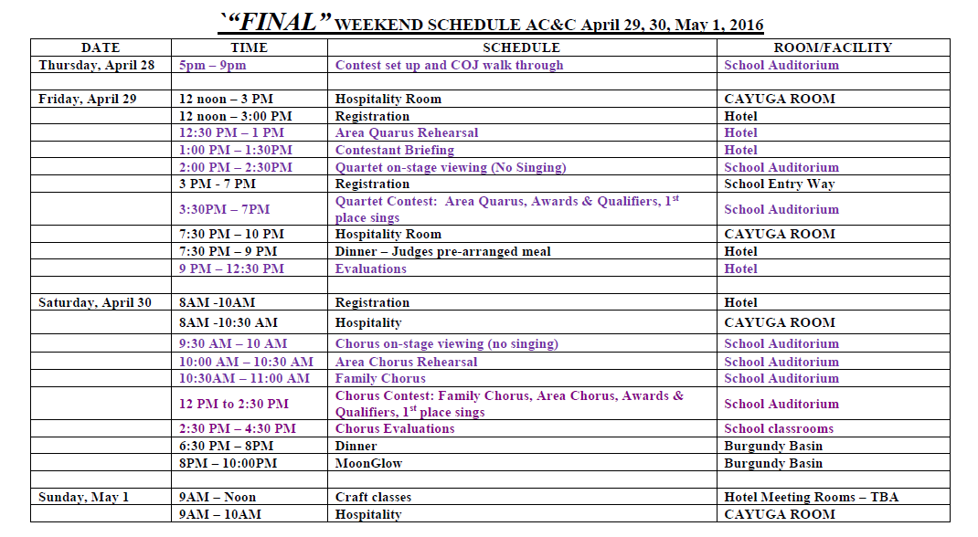
Due to the number of contestants and constraints with our facility contracts, please be aware of some major changes (noted in red) to the weekend schedule.

Riser Clarification: Risers for all choruses are five, six-foot risers with four steps and a back rail.

Safe Travels: Please drive safely. The roads leading to the school are country roads. Please watch out for deer!

Friday: Please enter the school building at Entrance 30. Quartets may enter the school no earlier than 2:00 pm and go directly to the auditorium. You may enter your classrooms at 2:30 pm.

Saturday: Please enter the school building at Entrance 30. You may enter the school no earlier than 9:00 am.

Music Boosters Food Sale: The prices run from $0.50 - $3.00. Food will be available by 9:30. The first pizzas will arrive around 11:15. There is no food allowed in the classrooms. Please eat in the cafeteria.

Saturday Morning Breakfast Menu
Assorted Muffins (blueberry, banana, apple, chocolate chip)
Granola Bars, Breakfast Bars
Fruit (apples and bananas)
Orange/Apple Juice
Tea, Coffee, Hot Chocolate

Saturday lunch
Pizza
Subs
Assorted Chips
Cookies
Fruit (apples and bananas)
Granola Bars
Popcorn
Orange/Apple Juice
Coffee, Tea, Hot Chocolate
Assorted Sodas

CONTEST ‘ETIQUETTE’
*NO alcohol, open or not, on school grounds
*NO smoking on school grounds
*NO talking/singing along while contestants perform
*NO photography or recording
*NO food in classrooms or auditorium
*Enter/exit auditorium when doors are officially open

PLEASE AND THANK YOU!

